Introducing Beiersdorf’s Executive Board

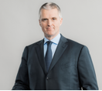
Stefan F. Heidenreich, born in 1962, graduated with a degree in business administration from Kiel University, Germany. He then joined Procter & Gamble, where he managed brands including Pampers, Ariel, and Crest between 1987 and 1992. In 1992, he moved to Reckitt Benckiser, where he was responsible for market expansion of the Laundry & Cleaning segment in Eastern Europe. Following a two-year spell at Bertelsmann, he joined the Executive Board of the international Hero group, headquartered in Switzerland. He has been Chairman of the Executive Board of Beiersdorf AG since April 26, 2012, responsible for the Corporate Development, Internal Audit, Supply Chain and Pharmacy functions, for business in Germany, Switzerland, China and Japan, and for the North America region and the La Prairie group.

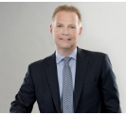
Jesper Andersen, born in 1970, studied Economics at the Aarhus School of Business in Denmark and at San Francisco State University in the U.S. In 1994 he began his professional career at Colgate Palmolive in Denmark as a Financial Analyst. Over the next 20 years he covered various financial management positions inside the company and around the world. Among his first stops were Brussels, Paris, Geneva and Athens. From 2009 to 2012 Jesper Andersen was once again in Geneva where he was responsible for the Europe and South Pacific regions as the Divisional Controller. From 2012 to 2014 he was Vice President of Finance responsible for the Asia Division in Hong Kong and lastly, from 2014 to 2015 in New York as Vice President of Finance for the North American Division. Since May 2015 Jesper Andersen has been a member of the Board at Beiersdorf AG. Since September 2015 he is responsible for Finance (including Legal and Compliance), Controlling and IT.

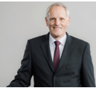
Dr. Ulrich Schmidt, born in 1953, graduated with a degree in economics and business administration from Kiel University. After obtaining his doctorate, Dr. Schmidt began his professional career at Beiersdorf in 1983 in Finance and Accounting. After just one year, he was appointed Head of Treasury. Numerous other senior management positions at Beiersdorf’s tesa affiliate and at the parent company followed. From 1999 to 2010, Dr. Schmidt was Managing Director of the Beiersdorf affiliate in Vienna and was responsible for business in Central and Eastern Europe. He has been a member of the Executive Board since January 1, 2011. His areas of responsibility are Finance (including Legal and Compliance), Controlling, IT and the Latin America region.

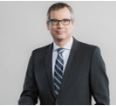
Ralph Gusko, born in 1961, completed a binational degree in business administration with a major in marketing from Saarbrücken, Germany and Metz, France. He has worked at Beiersdorf for 22 years, holding a variety of posts in central Brand Management and in regional markets. From 2001 to 2005, he built a successful track record in brand management as Marketing Manager Germany. As General Manager of South Korea from 1995 to 2001 and of the Thailand, Indochina & West Asia region from 2005 to 2009, he was responsible for the successful establishment and expansion of Beiersdorf’s business in these areas. In 2009, Ralph Gusko became General Manager Northern Europe with responsibility for the United Kingdom, Ireland, Denmark, Sweden, Norway, Finland, and Iceland. He has been a member of the Executive Board since July 1, 2011 and is responsible for Brand Management Consumer, Research & Development, and the Far East region (North- and South/East-Asia (excluding China and Japan), Australia.

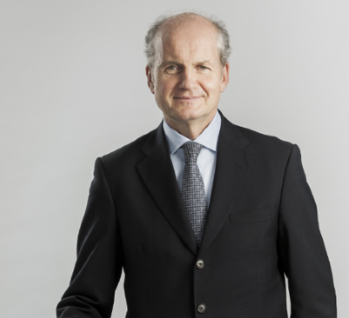
Thomas Ingelfinger, born in 1960, studied business administration at the University of Konstanz in Germany, the University of Grenoble in France, and Rutgers University in the USA. He began his professional career in 1986 as a trainee with Beiersdorf AG in Hamburg. After holding positions as Product Manager and International Brand Manager, he was Managing Director of Beiersdorf UK Ltd. (including the Republic of Ireland) between 1993 and 1997. In 1997, Thomas Ingelfinger returned to Hamburg as Marketing Director of Beiersdorf AG. From 2005, he was again appointed Managing Director, this time with responsibility for Beiersdorf SpA in Italy. From 2011 to 2014, Thomas Ingelfinger was General Manager for Beiersdorf’s Southern Europe region. He has been a member of the Executive Board of Beiersdorf AG since July 1, 2014, where he is responsible for the Europe region (excluding Germany and Switzerland).

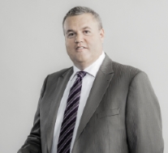
Stefan De Loecker, born in 1967, graduated with a degree in economics from the University of Antwerp in Belgium. From 1990 onwards, he held a number of posts at Nestlé, including in Marketing and Key Account Management. Between 1999 and 2011, he was appointed to a variety of management positions at Nestlé, including acting as a member of the Executive Board of Nestlé Deutschland AG and Chief Executive Officer (CEO) of Nestlé Rossiya LLC in Moscow. From 2011, he was Chief Operating Officer for Tesco plc in the United Kingdom and CEO of Tesco Slovakia. He joined Beiersdorf AG in the middle of 2012, initially as Corporate Senior Vice President. Since July 1, 2014, he has been a member of the Executive Board with responsibility for the Near East region (including Africa, Middle East, India, Turkey, Russia/Ukraine/CIS).

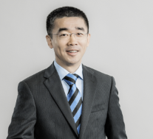
Zhengrong Liu, born in1968, studied education, political science and English at the Universities of Shanghai and Cologne. He joined the Bayer Group in Asia in 1997 and was Head of Human Resources at Bayer China in Beijing between 1998 and 2001. On moving to Shanghai, he became Deputy General Manager for Bayer China Ltd., the holding company for the Chinese market. Liu was Regional Vice President Human Resources at Bayer Polymers Asia Pacific from 2002 to 2004. In 2004, he returned to Germany as Group Senior Vice President Human Resources for Lanxess AG in Leverkusen. In 2013, Zhengrong Liu moved to Beiersdorf AG, initially as Corporate Senior Vice President Human Resources and Services. He has been a member of the Executive Board since July 1, 2014 with responsibility for Human Resources, Corporate Communications, and Sustainability. He also holds the post of Labor Relations Director.

September 2015

